Group B: CO 4,5

Name of the Student: _____________________________________ Roll no: ___
CLASS: - T.E. IT Course: - HCI Lab.
Experiment No. 04
** Prototype and wire frame **

Date of Performance: Sign with Date:

Date of Performance: Sign with Date:

Marks: /10
/ /2022

Aim : Prototype and wire frame:

(Students are expected to choose a problem statement and identify –
Types of users going to use (age, experience, environmental conditions during use etc..)
Minimum 3 scenarios of use Create paper-based prototypes for scenarios.
Use any open-source tool to wire frame scenarios. )

Problem Statement
•Group of 4 Students are expected to choose a problem statement
•Select problem statement of sufficient complexity
•Real life problem or social Problem
E.g.
•Booking a cab-cab booking application
•Shopping online-E-commerce website
•Ordering food online
•Connecting and using meeting application

Persona
•Types of users going to use (age, experience, environmental conditions during use etc..)
•User Focus-
•know your users, Stakeholders
•who are they?-Are they young or old, experienced computer users or novices?
•probably not like you!-You may not be the only user
•talk to them-It is hard to get yourself inside someone else’s head, so the best thing is usually to ask them.
•participatory design -structured interviews about their job or life, open-ended discussions, or bringing the potential users fully into the design process.
•Let people tell how the things happen-trust you
•watch them-Although what people tell you is of the utmost importance, it is not the whole story.
•sitting and taking notes of how they spend a day, watching particular activities, using a video camera or tape recorder. It can be done in an informal manner or using developed methods such as ethnography or contextual inquiry
•use your imagination-A persona is a rich picture of an imaginary person who represents your core user group.
•involve many users-not possible, However, even if you cannot involve actual users you can at least try to imagine their experiences.
•https://www.youtube.com/watch?v=u44pBnAn7cM

Scenarios
•Minimum 3 scenarios of use Create paper-based prototypes for scenarios.
•Scenarios are stories for design: rich stories of interaction. They are perhaps the simplest design representation, but one of the most flexible and powerful.

•https://www.designorate.com/guide-ux-research-scenarios/

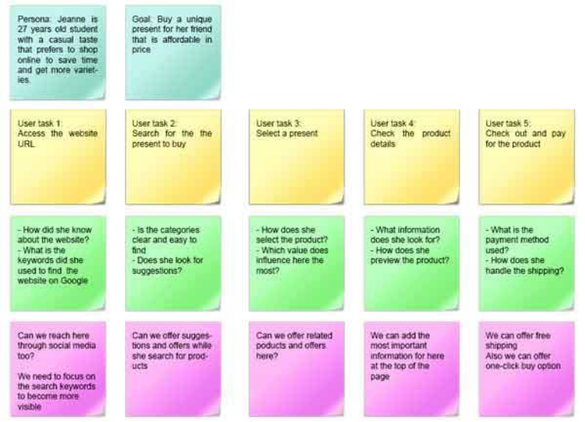
Paper Prototypes
•Paper prototyping is sketching screenshots on paper as substitutes for digital representations.
•https://www.uxpin.com/studio/blog/paper-prototyping-the-practical-beginners-guide/

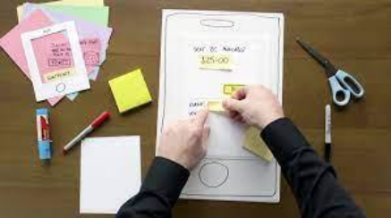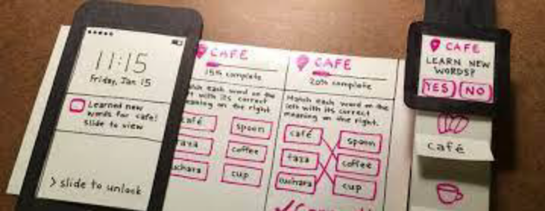

Wireframes
•Use any open-source tool to wire frame scenarios.
•Scenarios or storyboards. Usually, wire-frames look like page schematics or screen blueprints, which serve as a visual guide.
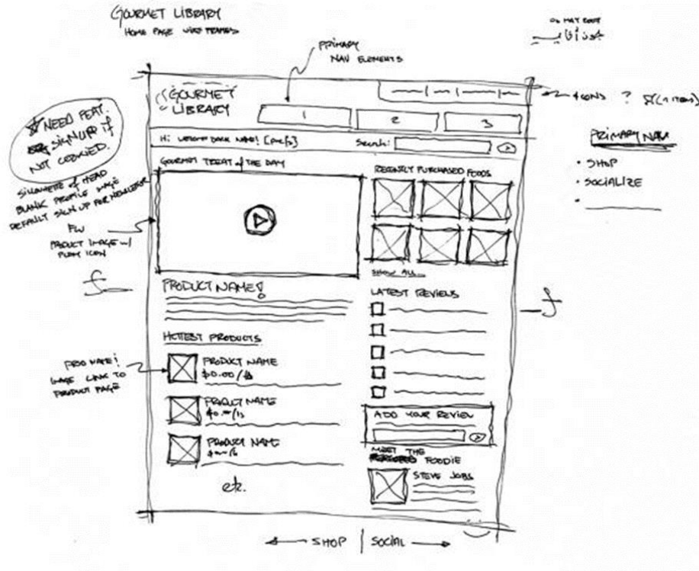
https://www.justinmind.com/blog/20-inspiring-web-and-mobile-wireframe-and-prototype-examples/
https://cacoo.com/blog/10-must-see-wireframe-examples-inspire-next-design/
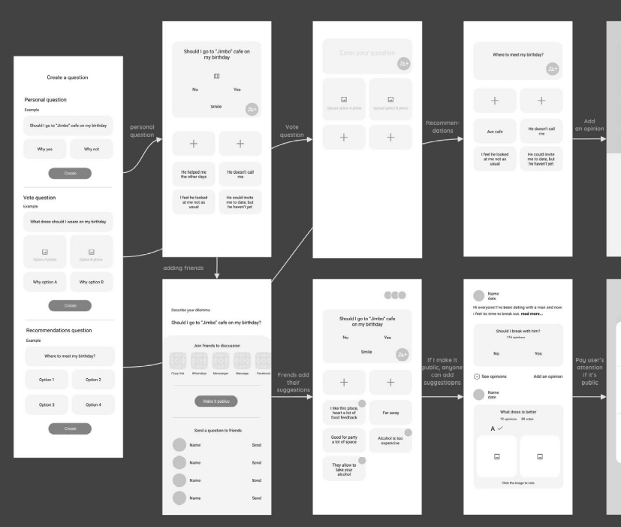

Conclusion: I understand the concept regarding with the frameworks

References: Prototype design made by me on paper

Group B: CO 4, 5
Name of the Student: ______________________________________ Roll no: ___
CLASS: - T.E. IT Course: - HCI Lab.
Experiment No. 05
** CSS **

Date of Performance: Sign with Date:

Date of Performance: Sign with Date:

Marks: /10
/ /2022

Aim : CSS:
(Students are expected to design minimum of 5 web pages using CSS for the problem statement chosen in assignment no. 4.
Apply CSS properties Border, margins, Padding, Navigation, dropdown list to page )

- Objectives:
- Understand the how to add CSS into HTML page.
- To develop an understanding of how CSS can enhance the design of a webpage.
- Apply different CSS properties to page.
- Implementation Steps:
- First create web page.
- Write CSS and call it.
- Theory
- CSS stands for Cascading Style Sheets.
- CSS describes how HTML elements are to be displayed on screen, paper, or in other media.
- CSS saves a lot of work. It can control the layout of multiple web pages all at once.
- External stylesheets are stored in CSS files.
Syntax:
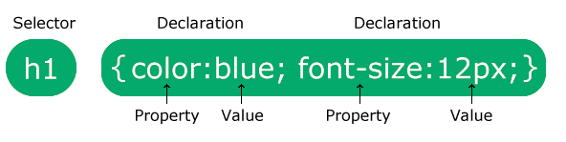
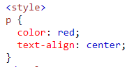
Example:
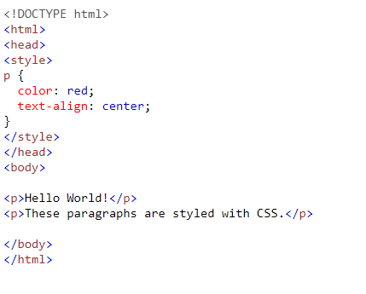

Name of Property | Meaning
Border | The CSS border properties allow you to specify the style, width, and color of an element's border. The border-style property specifies what kind of border to display. Ex -> Dotted, dashed, solid, double, groove, ridge, inset, outset, none, hidden.
Margins | Margins are used to create space around elements, outside of any defined borders.  Ex-> margin-top, margin-right, margin-bottom, margin-left.
Padding | Padding is used to create space around an element's content, inside of any defined borders.  Ex-> padding-top, padding-right, padding-bottom, padding-left.
Navigation Bars | Having easy-to-use navigation is important for any web site.  With CSS you can transform boring HTML menus into good-looking navigation bars.  Ex-> Navigation Bar = List of Links, navigation bar is basically a list of links, so using the <ul> and <li> elements
Dropdown list | Create a hoverable dropdown with CSS.  Ex-> Create a dropdown box that appears when the user moves the mouse over an element.

- Expected Outcomes:
- Page must be seen as per the paper based prototype.
- Design must be easily understandable.

Conclusion: I understand the concept related to CSS assignment.

References: https://www.w3schools.com/css/

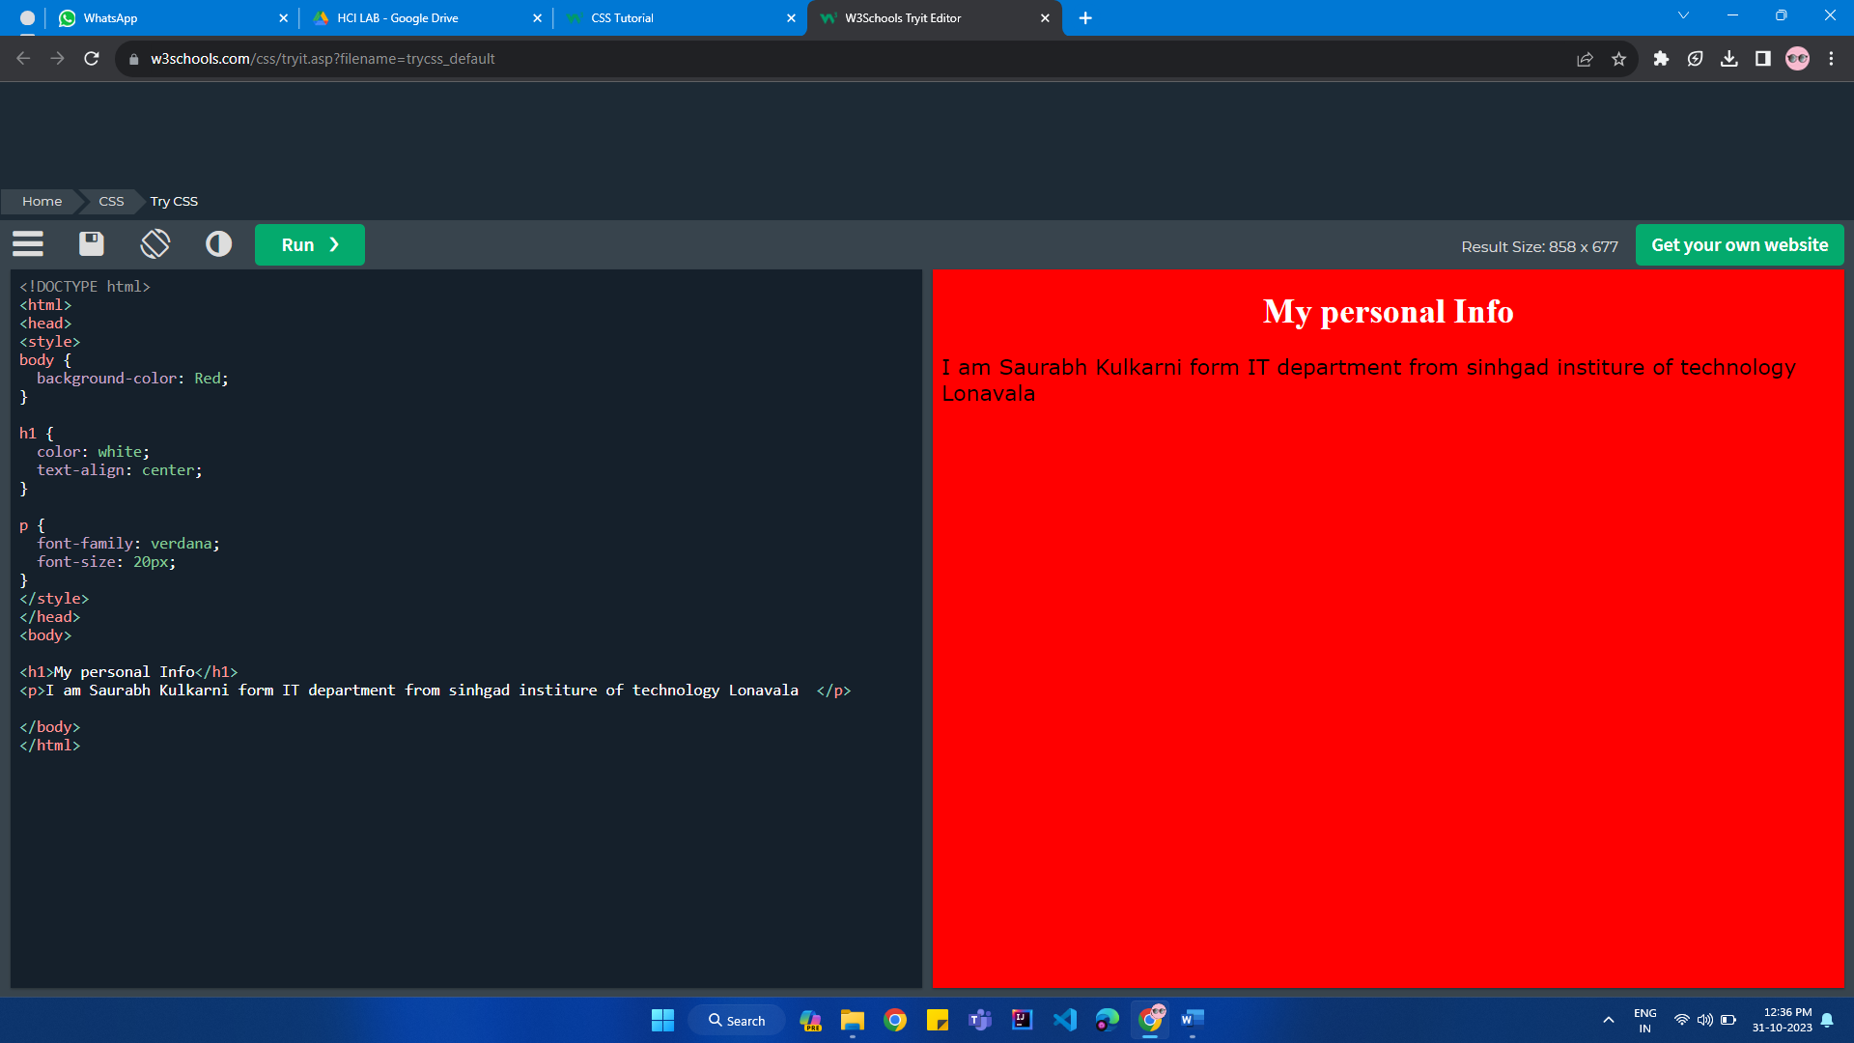

Group C: CO 5, 6
Name of the Student: ______________________________________ Roll no: ___
CLASS: - T.E. IT Course: - HCI Lab.
Experiment No. 06
** CMS tool **

Date of Performance: Sign with Date:

Date of Performance: Sign with Date:

Marks: /10
/ /2022

Aim : CMS tool:
(Develop website using any CMS tool which falls into one of the categories blog, social networking, News updates, Wikipedia, E-commerce store.
Website must include home page, and at least 5 forms. Use WordPress/ Joomla/ Drupal /PHP/ CSS/Bootstrap/ JavaScript.)

- Objectives:
- Understand the how to use CMS tool to create Website.
- To develop Website must include home page, and at least 5 forms.
- Use WordPress/ Joomla/ Drupal /PHP/ CSS/Bootstrap/ JavaScript to create webpage.
- Theory
- CMS stands for Content Management System.
- A content management system (CMS) is a software application that enables users to create, edit, collaborate on, publish and store digital content.
One of the CMS tool i.e. PHP syntax given here…….
Syntax:
A PHP script can be placed anywhere in the document.
A PHP script starts with <?php and ends with ?>:

<?php
// PHP code goes here
?>
The default file extension for PHP files is ".php".
A PHP file normally contains HTML tags, and some PHP scripting code.
Below, we have an example of a simple PHP file, with a PHP script that uses a built-in PHP function "echo" to output the text "Hello World!" on a web page:

Example
<!DOCTYPE html>
<html>
<body>
<h1>My first PHP page</h1>
<?php
echo "Hello World!";
?>
</body>
</html>

Conclusion: I understand the concept related to PHP assignment

References: 1)https://en.wikipedia.org/wiki/Content_management_system
2)https://www.w3schools.com/php/php_syntax.asp

Group C: CO 5, 6
Name of the Student: ______________________________________ Roll no: ___
CLASS: - T.E. IT Course: - HCI Lab.
Experiment No. 07
** Evaluation of Interface **

Date of Performance: Sign with Date:

Date of Performance: Sign with Date:

Marks: /10
/ /2022

Aim : Evaluation of Interface:

Students are expected to evaluate minimum of two products / software interface against known HCI evaluation.

Example: Microsoft Word
- Microsoft word is one of the most popular document editor.
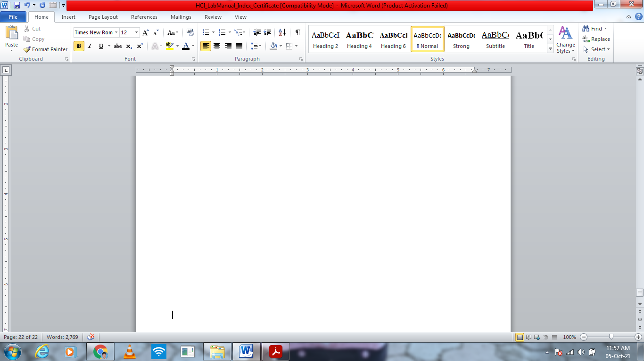

- It consist with 8 menus like File, Home, Insert, Page Layout, Mailings, Review, View. If you click on file menu, it consist with different subitems like save, save As, Open, Close, New Print, Help etc…
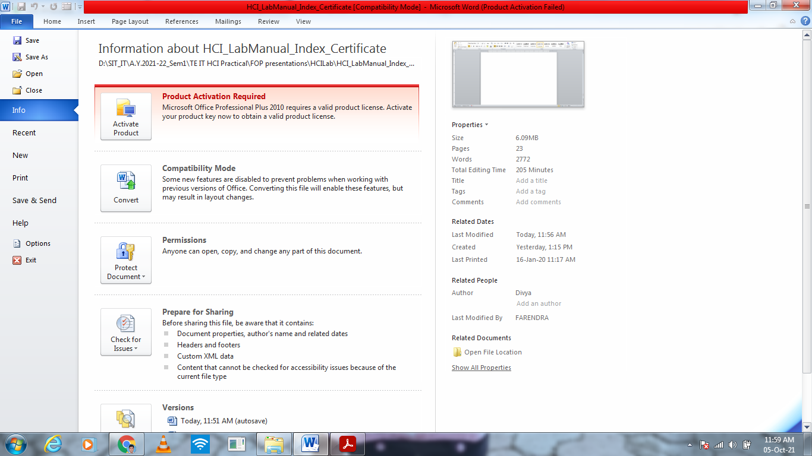
- If you want open new word file then click on open in file menu.
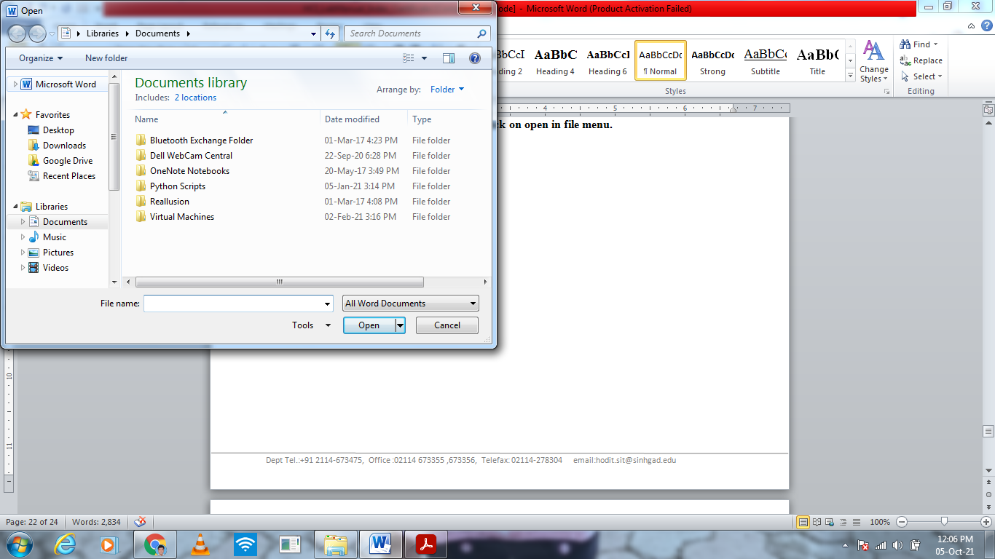

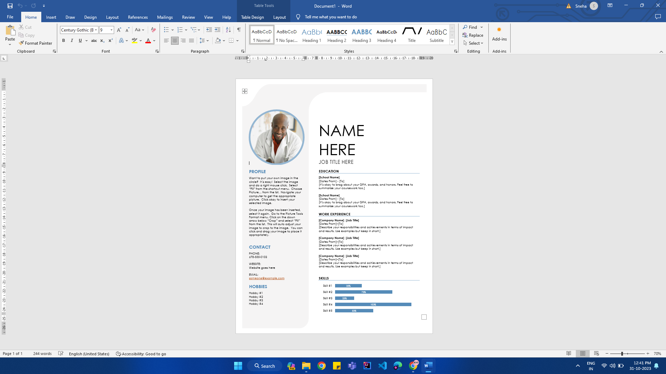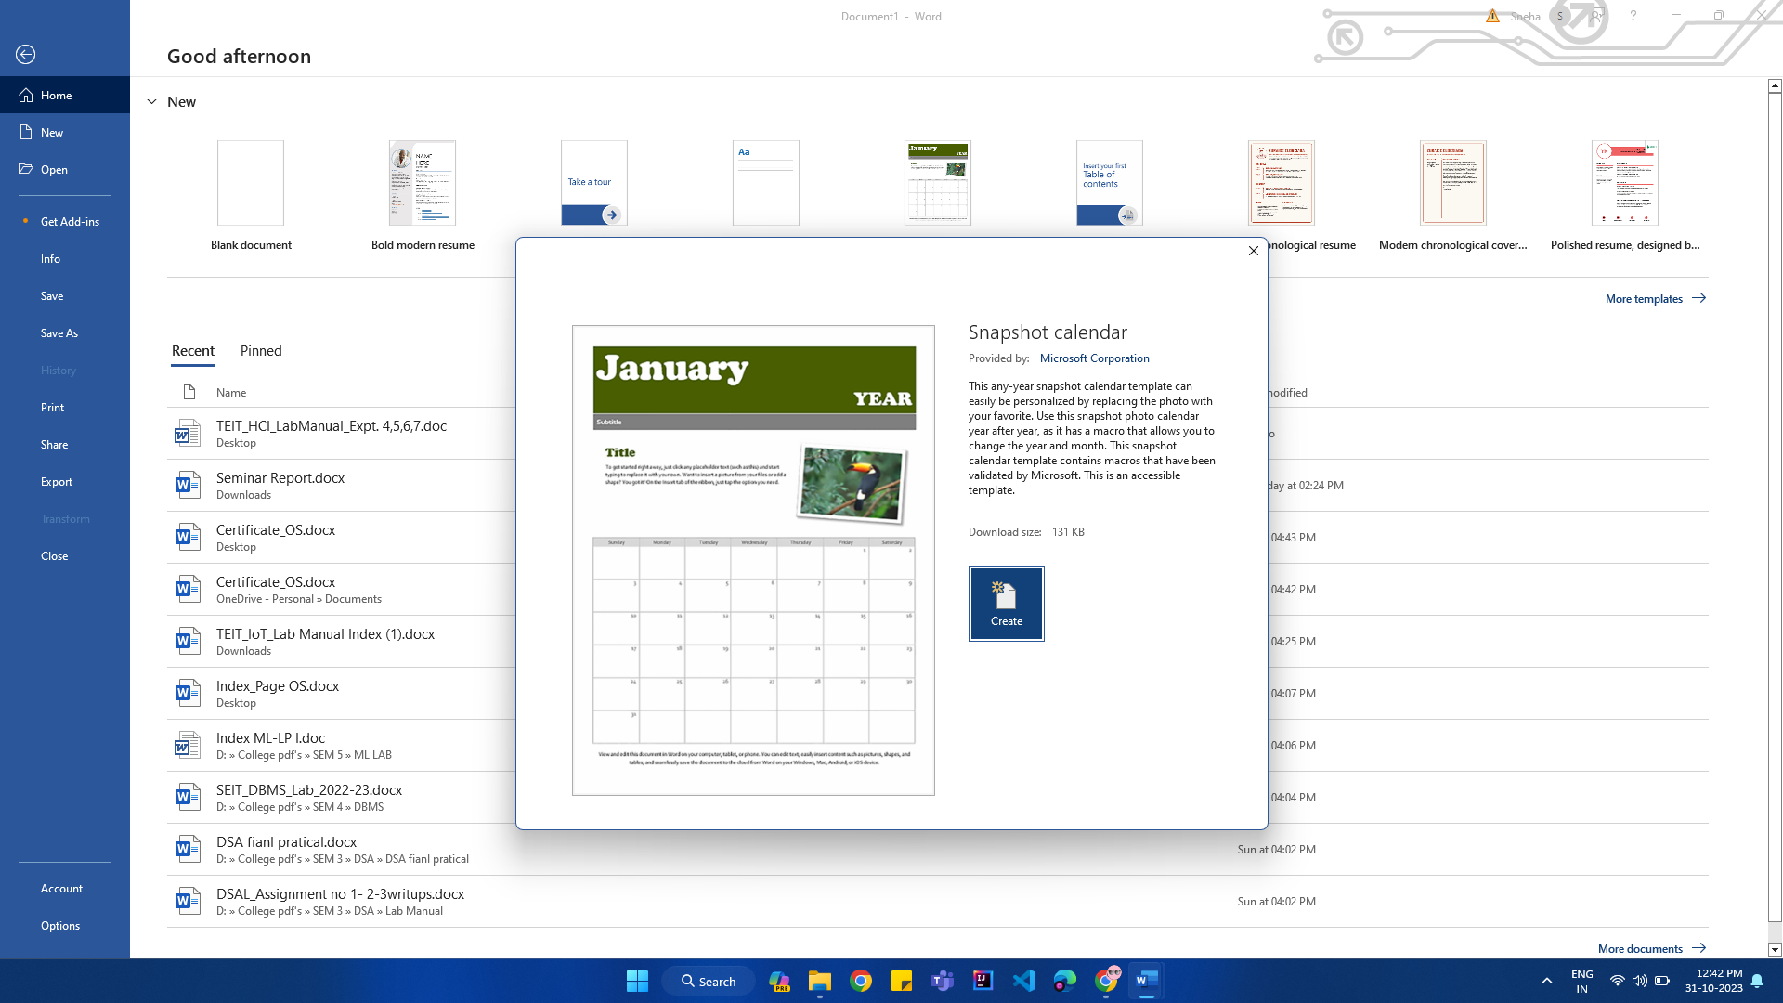

Conclusion: I understand the concept of MS Word templates.

References: MS Word document Evaluate by me

